Theme 4: Change Resistance — Time Manager
Project: Gotham City Hall Time Manager Rollout
Focus: Change Resistance, Stakeholder Strategy, Interface Design, & Communication Plan
Figma Prototype File: Time Manager — Role Dashboards Pivot (Figma Link)

1. Executive Summary & Context
The introduction of the new Time Manager application at Gotham City Hall is more than a software update; it is an organizational transition that directly impacts employee trust, working conditions, payroll accuracy, and daily operations.
Initial feedback indicated widespread skepticism and resistance. Employees expressed fear of micromanagement, field workers worried about accessibility, and managers feared heavy administrative burdens. To address these concerns, our strategy combines root-cause complaint analysis, a stakeholder management framework, role-based interface design, and a tailored, transparent communication plan.

2. Comprehensive Analysis of Employee Complaints
Rather than treating every feedback item as an isolated feature request, employee concerns are synthesized into eight primary themes. Each theme highlights the underlying organizational and human need that must be addressed by both the application and city policies.

1. Surveillance, Trust, and Micromanagement
- Symptom: Employees fear that time tracking will be used to monitor every minute, judge productivity unfairly, or penalize staff.
- Underlying Need: Transparency, trust, clear boundary rules, and explicit limits on how recorded data is utilized by management.

2. Irregular Hours, Night Shifts, and Overtime
- Symptom: Confusion and anxiety surrounding flexible schedules, emergency call-outs, consecutive night shifts, and premium rates.
- Underlying Need: Transparent time categorization, fair shift scheduling, and predictable pay calculation models.

3. Accuracy, Validation, and Accountability
- Symptom: Managers fear forgotten clock-outs, inaccurate manual entries, and an overwhelming burden of verifying records individually.
- Underlying Need: Efficient exception-handling workflows, automated alerts, self-service correction requests, and clear audit trails.

4. Accessibility and Access to Technology
- Symptom: Field workers, outdoor staff, drivers, and visually impaired employees worry they cannot easily use a web portal.
- Underlying Need: Mobile-first responsive views, high-contrast WCAG-compliant design, screen-reader compatibility, and offline/alternative entry options.

5. Training and Operational Support
- Symptom: Senior employees and Union leaders express concern that staff are expected to use new tools without proper guidance or technical support.
- Underlying Need: Practical hands-on training sessions, concise quick-reference guides, and accessible helpdesk support.

6. Scheduling, Leave, and Work-Life Balance
- Symptom: Public safety and sanitation personnel face sudden schedule shifts, back-to-back night duties, and opaque leave balances.
- Underlying Need: Advance schedule visibility, shift-rotation safeguards, and transparent tracking of vacation, sick leave, and rest hours.

7. Pay Fairness and Recognition
- Symptom: Disputes over unpaid travel time between sites, mandatory lunch breaks, on-call standby, and duties outside formal job descriptions.
- Underlying Need: Accurate raw time logs, explicit payroll rules defined by HR policy, and formal channels to raise pay discrepancies.

8. Coordination and Management Permissions
- Symptom: Department heads struggle with cross-team emergency staffing, while executive leadership lacks oversight on permission delegation.
- Underlying Need: Role-based access control (RBAC), team-level reporting dashboards, and clear administrative accountability.

3. Stakeholder Map & Analysis
Understanding stakeholder attitudes and commitment levels allows us to focus change management efforts where mistrust or influence is highest.

Stakeholder Group | Estimated Commitment / Attitude | Core Needs & Primary Concerns | Key Engagement Strategy
Office-Based Employees | Mixed / Hesitant | Simple tracking, minimal admin overhead, privacy protection, no micromanagement. | Showcase fast clock-in/out UI; emphasize self-service correction features.
Senior Employees | Receptive, but cautious | Simple interfaces, confidence with technology, dedicated support. | Provide patient, hands-on training workshops and printed quick guides.
Outdoor & Field Workers | Concerned | Quick entry without a desktop PC, mobile access, reliable sync. | Demonstrate mobile interface during shift briefings; support offline logs.
Night-Shift & Emergency Staff | Highly Concerned | Accurate shift tracking, fair schedule distribution, night-rate pay accuracy. | Highlight explicit night-hour counters and automated shift balance warnings.
Disabled Employees | Requires Accommodation | Screen-reader support, keyboard navigation, high-contrast layouts. | Conduct accessibility walkthroughs; incorporate WCAG AAA design standards.
Managers & Team Leaders | Mixed / Practical Concerns | Streamlined verification, exception-only reviews, clear audit trails. | Provide manager dashboards that highlight missing clock-outs automatically.
HR & Payroll / Accounting | Supportive / Operational | Accurate category separation, clean export formats, compliance reporting. | Deliver granular time-category breakdowns (Ordinary, Night, Overtime, Comp-time).
Union Representatives | Critical / Influential | Worker rights protection, fair policies, adequate training, data privacy guarantees. | Early consultation meetings, transparent policy discussions, formal written responses.
Top Management / Execs | Strongly Supportive | System adoption, organizational governance, risk mitigation, audit logs. | Offer executive overview dashboards and role-permission control settings.
City Hall Commission | Project Sponsor | Successful rollout, public service continuity, minimized labor friction. | Report on adoption metrics, training completion rates, and feedback resolution.

4. User Persona Requirements: "Who Needs What?"
To keep software development focused on user value, requirements are grouped by operational roles:

Primary Users: Employees
- Needs: A frictionless way to record hours, view personal time sheets, understand pay categories, and request corrections.
- Key Features: One-click clock in/out, weekly hour counters, night shift indicator, missing entry alerts, self-service correction request modal.

Operational Users: Managers & Team Leaders
- Needs: Oversight of team hours without needing to manually inspect every single employee record.
- Key Features: Exception summary cards (missing clock-outs, schedule conflicts), team shift balance counters, quick approval workflows, audit trail log.

Administrative Users: HR, Payroll, & System Admins
- Needs: Reliable data extraction, administrative governance, policy configuration, and security control.
- Key Features: Time category breakdown (Ordinary, Night, Overtime, Compensation), role permission assignment, exportable payroll reports, audit oversight.

Key Influencers: Union Representatives
- Needs: Proof that the tool protects workers, respects privacy, and does not replace agreed labor contracts.
- Key Strategy: Clear separation between data recording (software function) and labor policy decisions (HR/Union governance).

5. Application Architecture & Feature Priority Plan
Features are prioritized into three implementation tiers to prevent scope creep while addressing core complaints from Day 1.
+-------------------------------------------------------+
| ESSENTIAL (V1.0) |
| • Clock In/Out & Personal Logs |
| • Missing Clock-out Alerts & Correction Workflow |
| • Mobile Responsive & High-Contrast UI |
| • Role-Based Access Control (RBAC) |
| • Time Category Separation (Night, Overtime, Ordinary)|
+-------------------------------------------------------+
|
v
+-------------------------------------------------------+
| IMPORTANT (V1.1) |
| • Team Exception Dashboard & Quick Approvals |
| • Shift Rotation Warnings & Schedule Calendar |
| • Integrated Help Center & Video Tutorials |
| • Leave & Absence Overview Summary |
+-------------------------------------------------------+
|
v
+-------------------------------------------------------+
| DISCUSS / POLICY DECISIONS |
| • Emergency Call-Out / Bat-Signal Integration |
| • Automatic Travel & Meal Break Compensation Rules |
| • Advanced Custom Allowance Engines |
+-------------------------------------------------------+

Categorization & Payroll Rule Framework
The system never merges all hours into a single total. To maintain transparency, hours are logged across distinct categories:
- Ordinary Working Hours: Standard daylight working hours.
- Night-Shift Hours: Hours worked within the designated night window (e.g., 20:00–04:00).
- Overtime Hours: Hours exceeding contract thresholds.
- Compensation-Time Hours: Accrued time off in lieu of pay.
Crucial Policy Boundary: The application records time, but does not formulate policy. Questions such as "does walking between sites count as paid time?" require HR and Union agreement. The app implements and displays the agreed policy transparently.

6. Interface Mockup Overview (Figma Prototypes)
The Figma design file includes three specialized role-based dashboard wireframes aligned with the Vue/ChartManager design system:
Access the Figma Wireframe File

Mockup 1: Employee Dashboard (01 — Employee Dashboard)
- Goal: Quick, accessible, and transparent daily time logging.
- Key Components:
  - Prominent Clock In / Clock Out action button with current shift preview.
  - Weekly Stats Widget: Summary of accumulated hours () and night shifts ().
  - Recent Time Entries Table: Immediate visual flag for missing clock-outs (e.g., "Wednesday · Missing clock-out · Needs attention").
  - Analytics Charts: Bar and trend charts powered by ChartManager displaying daily hour distributions.
  - Support & Correction Link: Direct entry point to submit time adjustment requests.

Mockup 2: Manager Dashboard (02 — Manager Dashboard)
- Goal: Minimize administrative friction through exception-driven management.
- Key Components:
  - Team Snapshot Counters: Total team members (), missing clock-outs (), night shifts flagged ().
  - Needs Attention Queue: Direct action cards highlighting missing clock-outs and schedule conflicts for rapid review.
  - Shift Balance Summary: Visual distribution of day vs. night assignments.
  - Audit Trail Link: Full transparency on who approved or modified time entries.

Mockup 3: Administrator Dashboard (03 — Administrator Dashboard)
- Goal: High-level operational oversight, security control, and payroll export management.
- Key Components:
  - System Metric Cards: Total workforce (), active teams (), pending reviews (), permission updates ().
  - Time & Payroll Category Configuration: Dedicated management panels for Ordinary, Night, Overtime, and Comp time.
  - Roles & Permissions Matrix: Granular controls to assign or restrict manager capabilities.
  - Audit & Compliance Oversight: Log of administrative actions and report export tools.
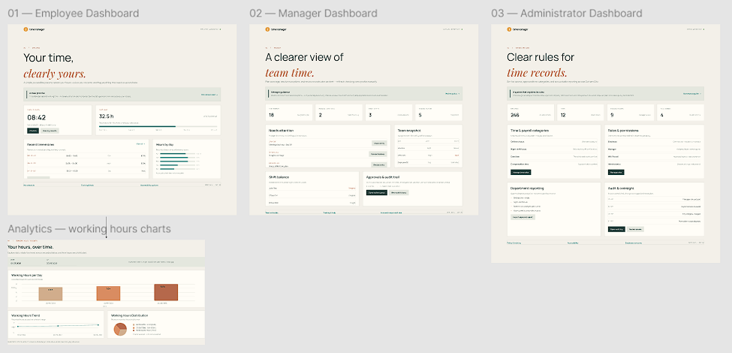

7. Multi-Audience Communication Strategy
To rebuild trust, communications are customized for each specific group rather than using a single generic announcement.
Target Audience | Channel / Action | Core Message & Focus
All Staff | Launch Email & FAQ Document | Clear explanation of system purpose, privacy limits, data usage, and support availability.
Senior Staff | Interactive Hands-on Workshops | "Learn at your own pace" guided training with printed reference cards.
Field & Outdoor Staff | Mobile Demos & Quick Guides | Demonstrating how to log hours in under 10 seconds from any mobile device.
Disabled Employees | Accessibility Walkthroughs | Demonstration of screen-reader support, contrast toggles, and keyboard shortcuts.
Managers | Workflow Optimization Seminars | Showing how exception queues save time compared to reviewing every record manually.
Night-Shift Teams | Shift Briefings (At Shift Start) | How night premiums, overtime thresholds, and emergency call-outs are logged accurately.
Union Reps | Formal Consultation Sessions | Reviewing safeguards, privacy protections, audit trails, and unresolved policy discussions.
HR / Accounting | Payroll Integration Workshops | Verifying time-category mapping and report export formats for payroll processing.
Exec Leadership | Executive Dashboard Briefing | Demonstration of role management, audit history, and compliance safeguards.

8. Sample Internal Communication: Staff Launch Email
SUBJECT: Introducing Time Manager: Training, Privacy, and What to Expect
Dear Colleagues,
We are preparing to introduce Time Manager, a new application designed to make recording and reviewing working hours simpler, clearer, and more consistent across Gotham City Hall.
We know that changing how we track time brings up important questions about privacy, workload, mobile access, night shifts, and how hours affect your pay. We are committed to providing clear, honest answers and full support throughout this transition.
WHAT THE APPLICATION DOES:
• Simplifies daily time tracking with a single-click clock in/out.
• Lets you view your own detailed records and weekly totals at any time.
• Allows you to flag mistakes or missing entries so they can be corrected quickly.
• Provides managers with simple summaries so they don't have to micromanage your daily work.
PRIVACY & FAIRNESS GUARANTEES:
Time Manager is built to record time, not to track your location or monitor your moment-to-moment activity. Your records are protected, and access is strictly restricted to authorized HR personnel and your direct supervisor.
TRAINING & SUPPORT FOR EVERYONE:
No one is expected to figure this out alone. We are launching hands-on training sessions, simple quick-start guides, and dedicated support channels for office, field, and night-shift staff before the system goes live.
We welcome your questions and feedback as we work together to build a fairer, more transparent workplace tool.
Sincerely,
Gotham City Hall Administration & Project Team

9. Implementation Roadmap & Checklist
- [x] Phase 1: Complaint & Root-Cause Analysis (Completed)
- [x] Phase 2: Stakeholder & Value Mapping (Completed)
- [x] Phase 3: Core Requirements & Feature Tiering (Completed)
- [x] Phase 4: Figma Role-Based Wireframe Creation (Completed)
- [ ] Phase 5: User Review & Prototype Feedback Walkthroughs
- [ ] Phase 6: Finalize HR/Union Policy Rules (Overtime, Travel Time)
- [ ] Phase 7: Roll out Audience-Specific Communications & Training
- [ ] Phase 8: Staggered Production Launch & Continuous Support

